**Results of Template Matching**

**9th April 2024**

**Catalogs**

**Templates:** 22 from double difference catalog.

|  |  |  |  |  |  |  |  |  |  |  |  |  |
| --- | --- | --- | --- | --- | --- | --- | --- | --- | --- | --- | --- | --- |
|  | dlat[m] | dlon[m] | dDepth[m] | ΔLat[m] | ΔLon[m] | ΔDepth[m] | Win[s] |  |  | Total | Detections  MAD≥9.0 | Detections  MAD≥9.5* |
| Catalog - 01 | 333.3 | 333.3 | 100 | 166.7 | 166.7 | 50 | 2 | 9.57 | 0.29 | 105 | 85 | 18 |
| Catalog - 02 | 555.5 | 555.5 | 100 | 277.775 | 277.775 | 50 | 2 | 9.49 | 0.28 | 129 | 109 | 20 |
| Catalog - 03** | 0 | 0 | 0 | 0 | 0 | 0 | 2 | 10.92 | 0.34 | 30 | 10 | 8 |
| Catalog - 04 | 444.4 | 444.4 | 100 | 222.2 | 222.2 | 50 | 2 | 9.54 | 0.29 | 115 | 95 | 22 |
| Catalog - 05 | 444.4 | 444.4 | 100 | 222.2 | 222.2 | 50 | 3 | 9.55 | 0.24 | 177 | 157 | 31 |

* Excluding templates

** Template Matching - ‘classic’

**Figure 1.** Analysis if the detections for different parameter configuration (see table). Dotted lines show MAD=9.5 and MAD=10. See next figure for close up.

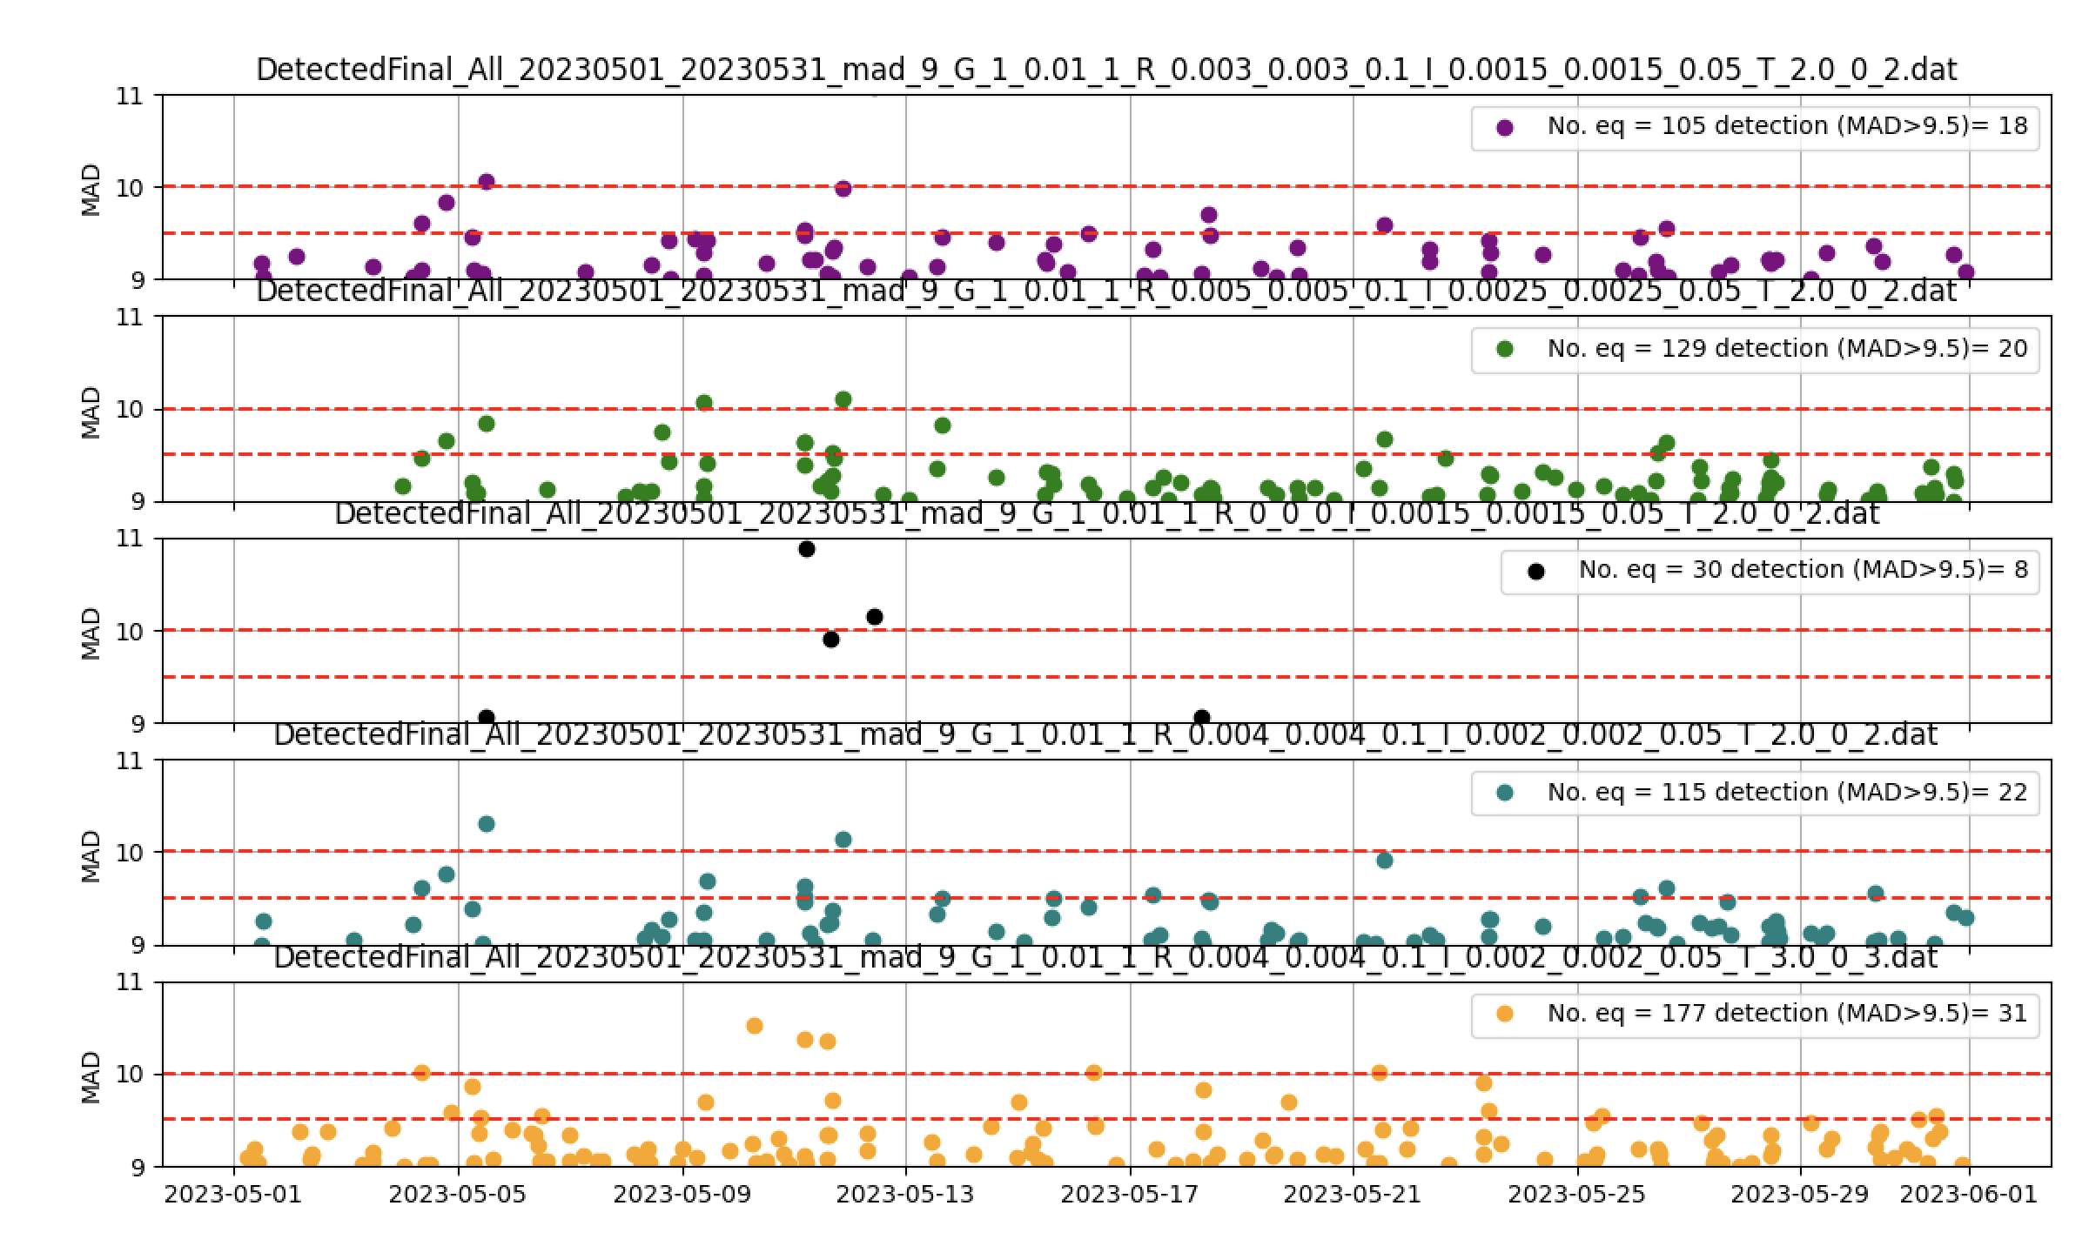

**Figure 2.** Detections between 9.0≤MAD≤11. Dotted lines shows the threshold limits for MAD=9.5 and MAD=10.

**Figure 3.** Detections versus time. (Top) Red dots indicate templates, blue dots detections. (Bottom) Squares templates, circles detections. For MAD values larger than 9.0.

**Figure 4.** Detections versus time. (Top) Red dots indicate templates, blue dots detections. (Bottom) Squares templates, circles detections. For MAD values larger than 9.5.